Create database db;

use db;

CREATE TABLE students (

ID int,

Name varchar(25) ,DBMS int OS int,BEFA int,DM int,JP int

);

select \* from students;

alter table students drop column OS;

alter table students add OS int;

insert into students values(561,'keerthi Renuka',25,21,22,21,23);

insert into students values(591,'Nitisha',25,23,21,19,24);

insert into students values(598,'Rachana',22,21,23,19,25);

insert into students values(581,'Vrinda',21,18,24,20,22);

insert into students values(569,'Vyshnavi',24,22,25,19,24);

select \* from students;

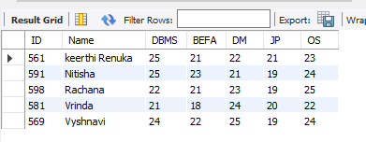

alter table students add primary key(ID);

truncate table students;

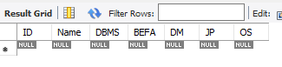

drop table students;